1. Install Jenkins and run Jenkins on port number 8081.   
     
   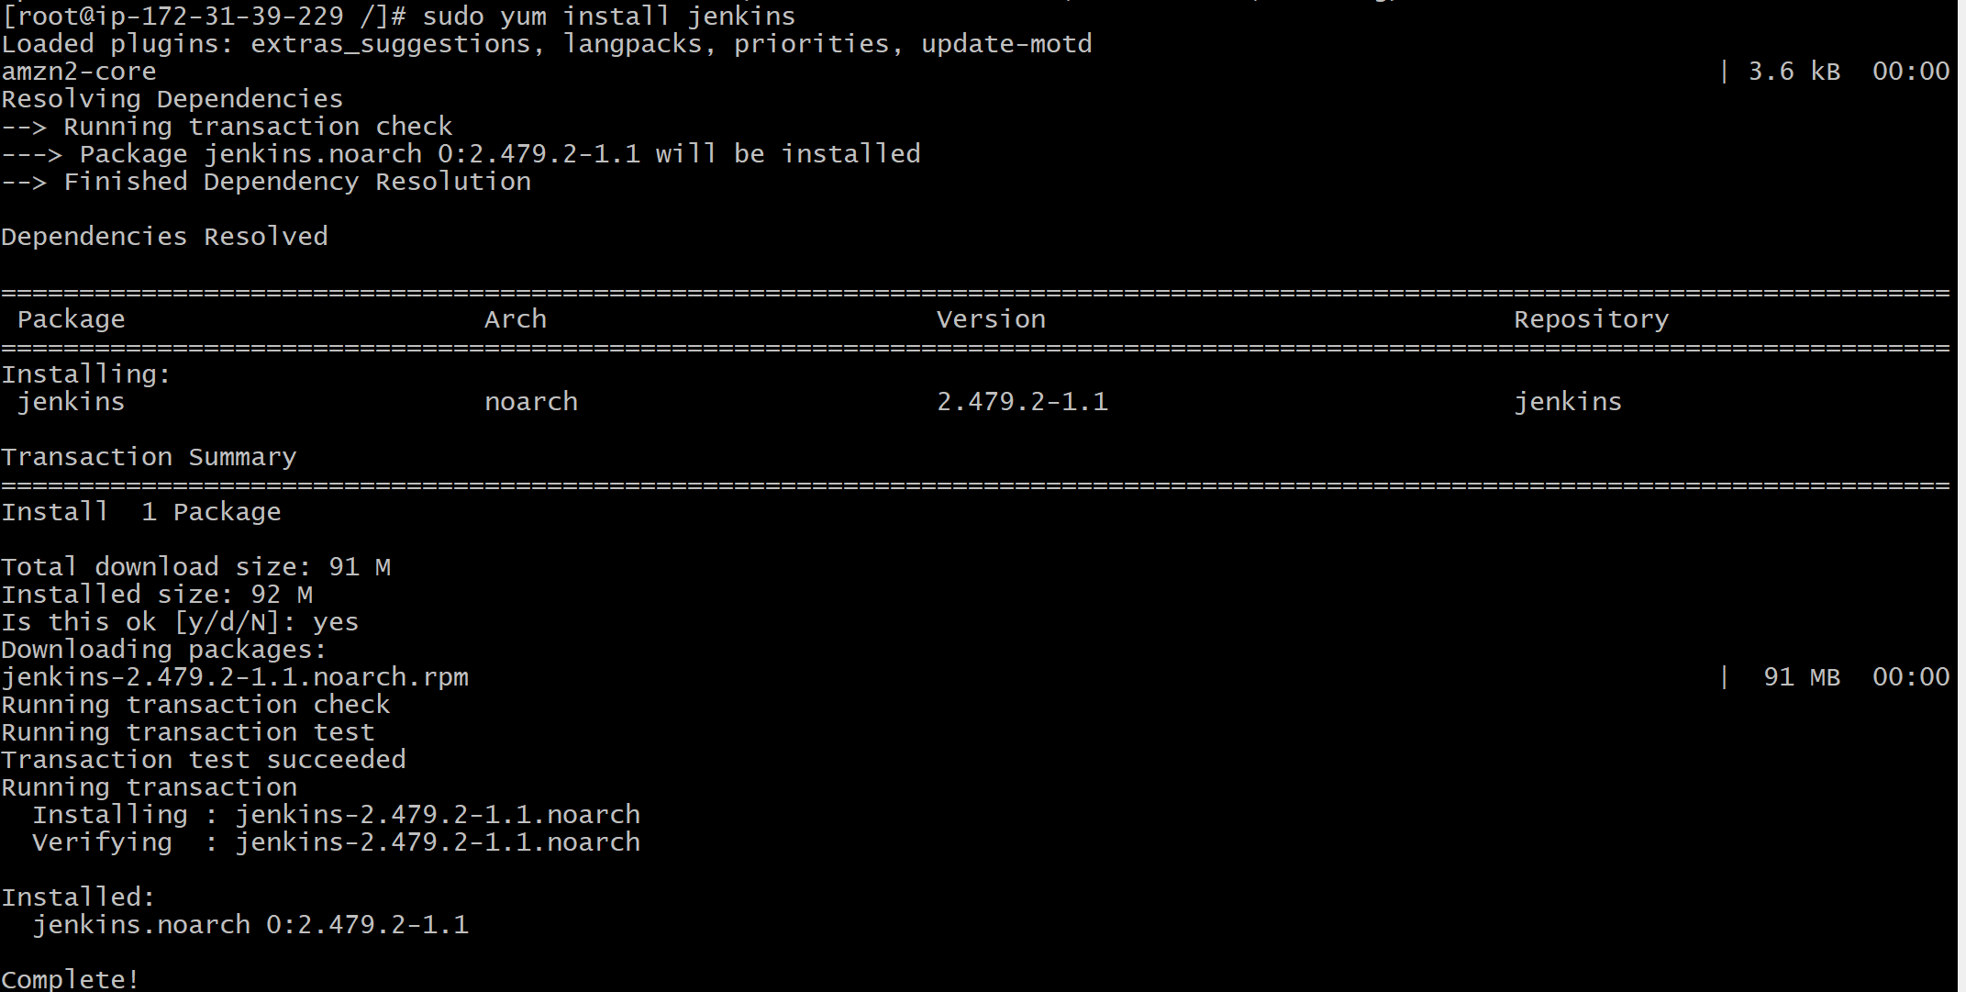  
     
     
     
   **/usr/lib/systemd/system/jenkins.service -- Jenkins port location**  
   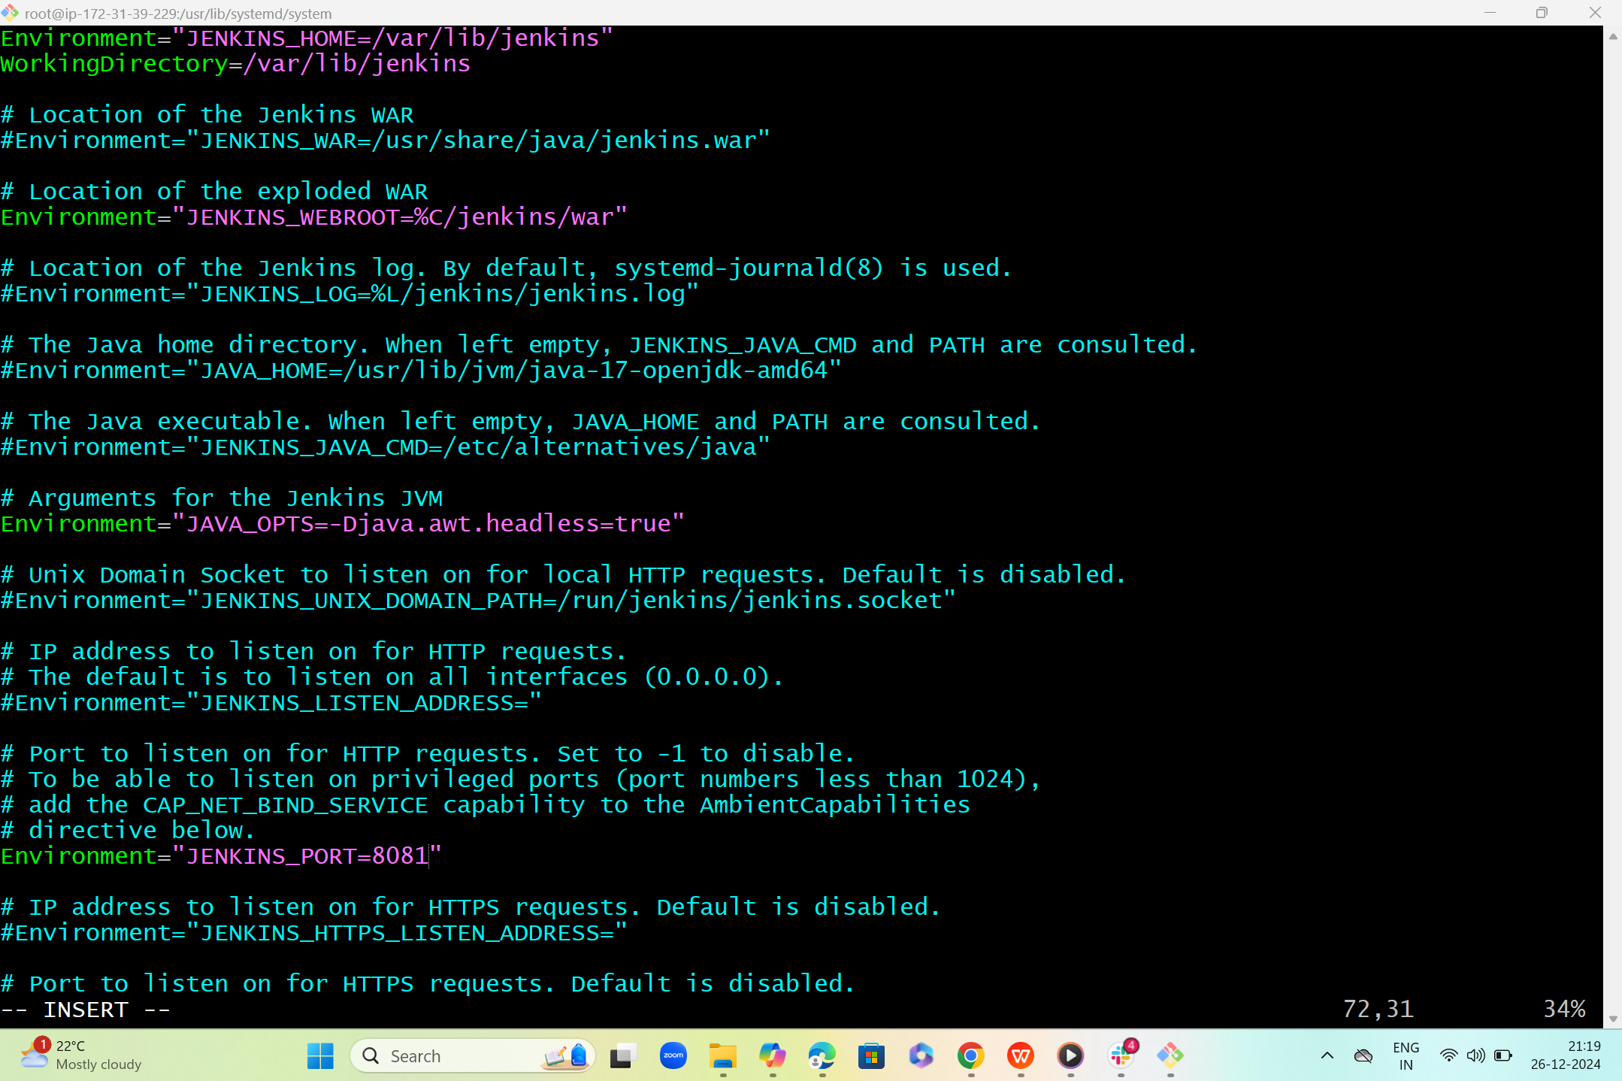

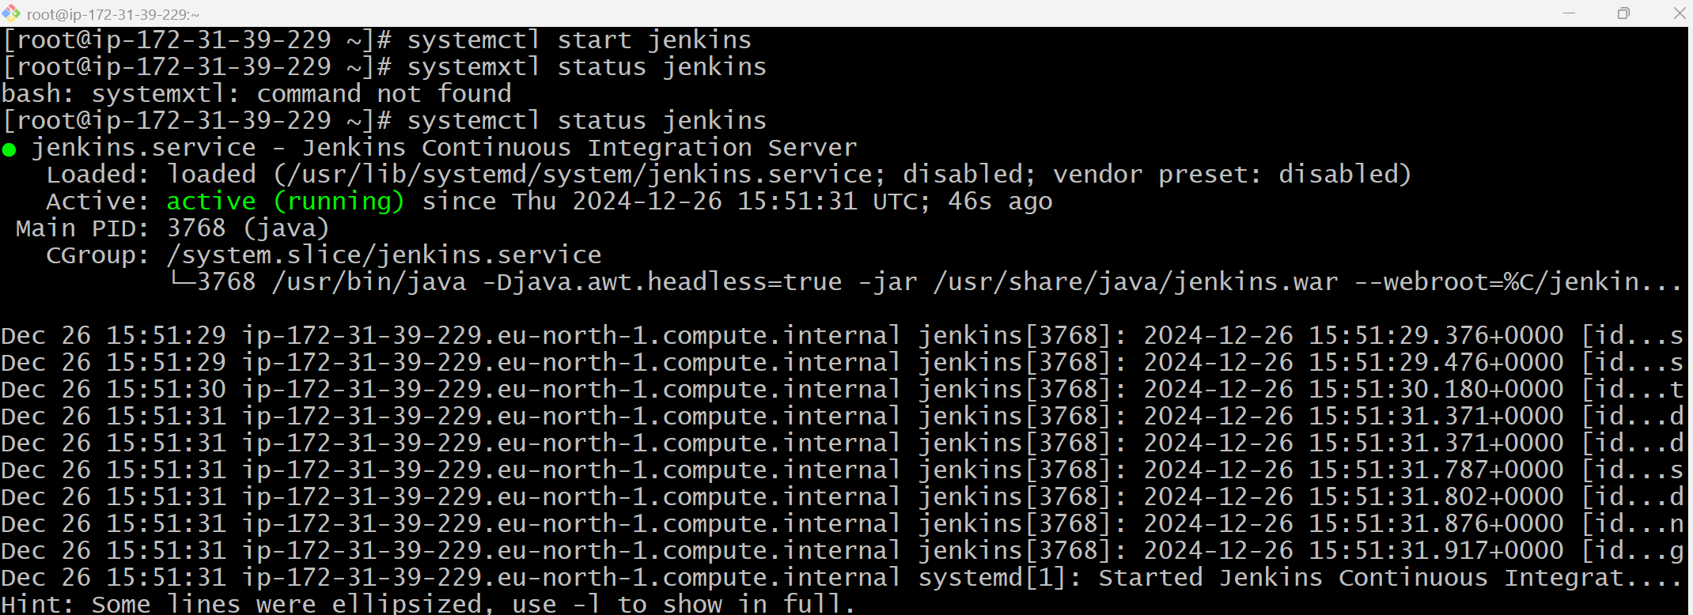  
  
  
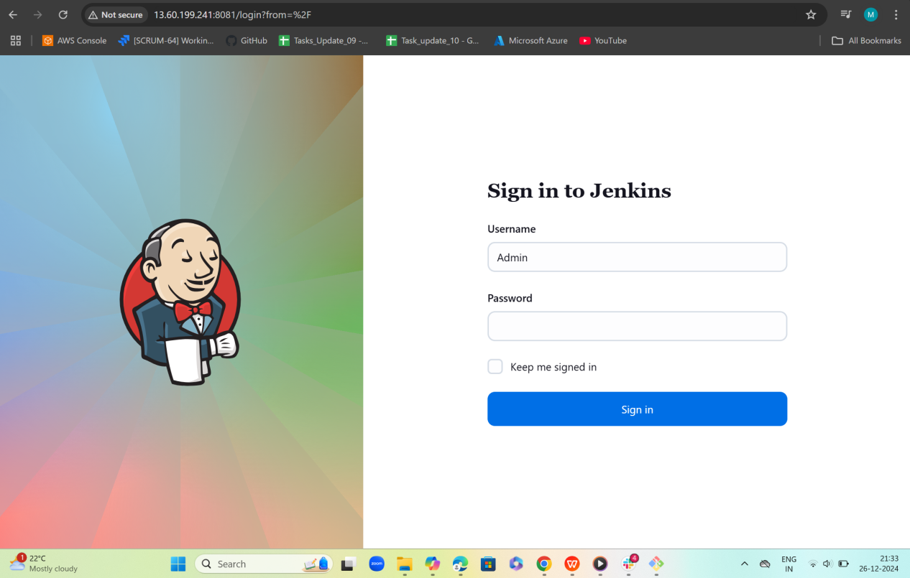  
  
  
2) Secure the Jenkins server.   
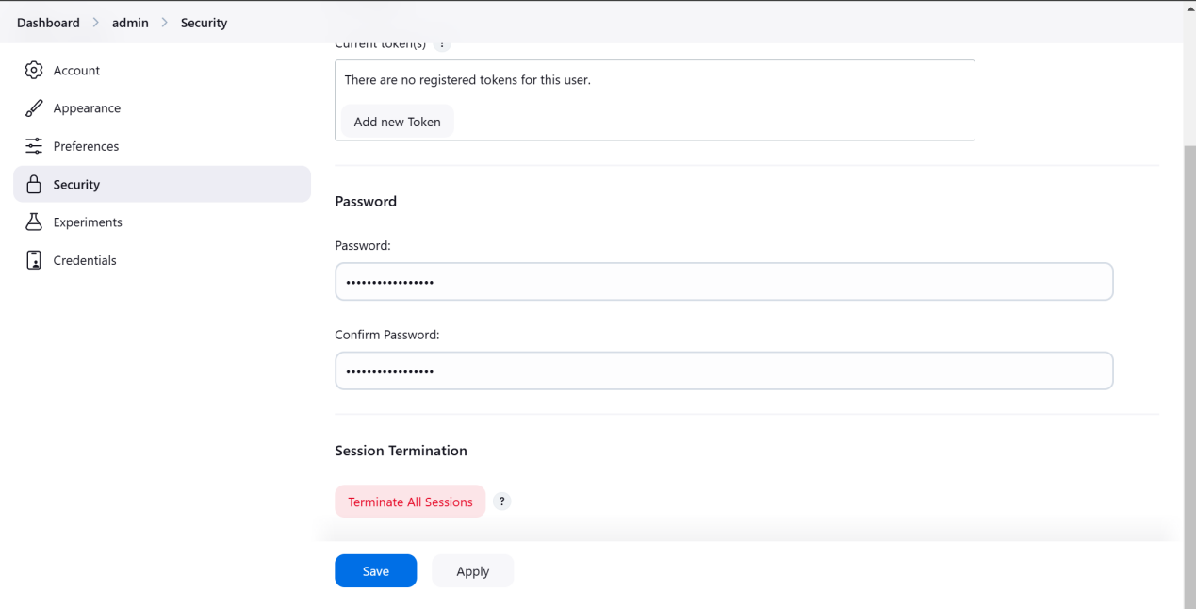  
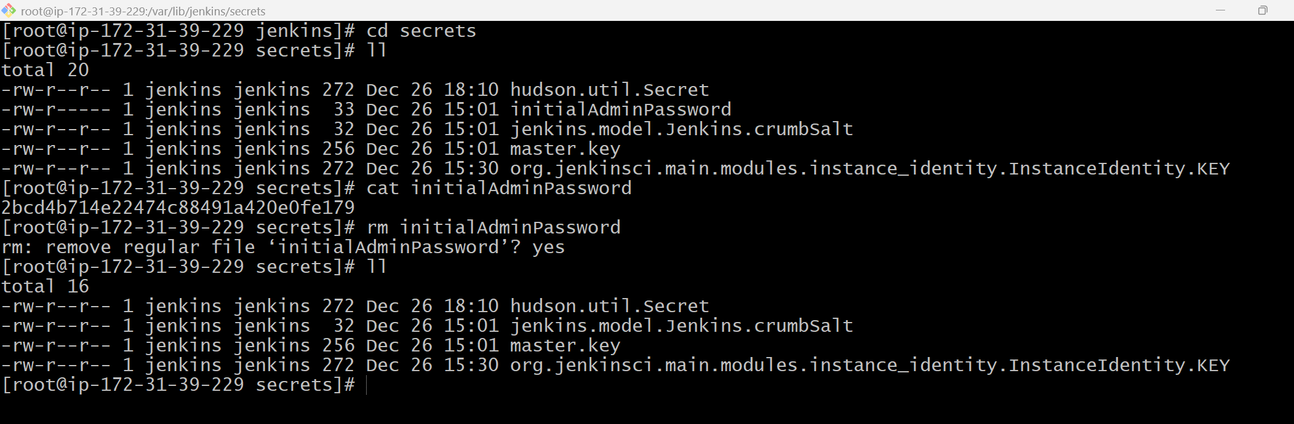  
  
  
  
  
3) Create users called DevOps, testing in Jenkins with Limited   
access.  
  
  
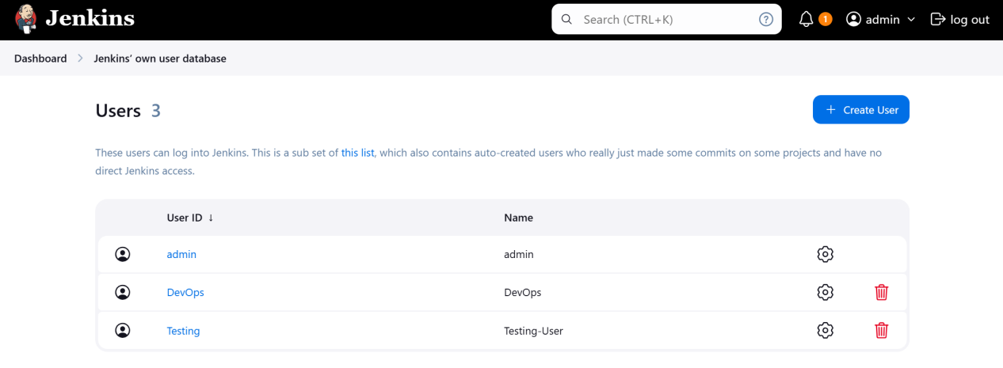  
  
  
  
  
  
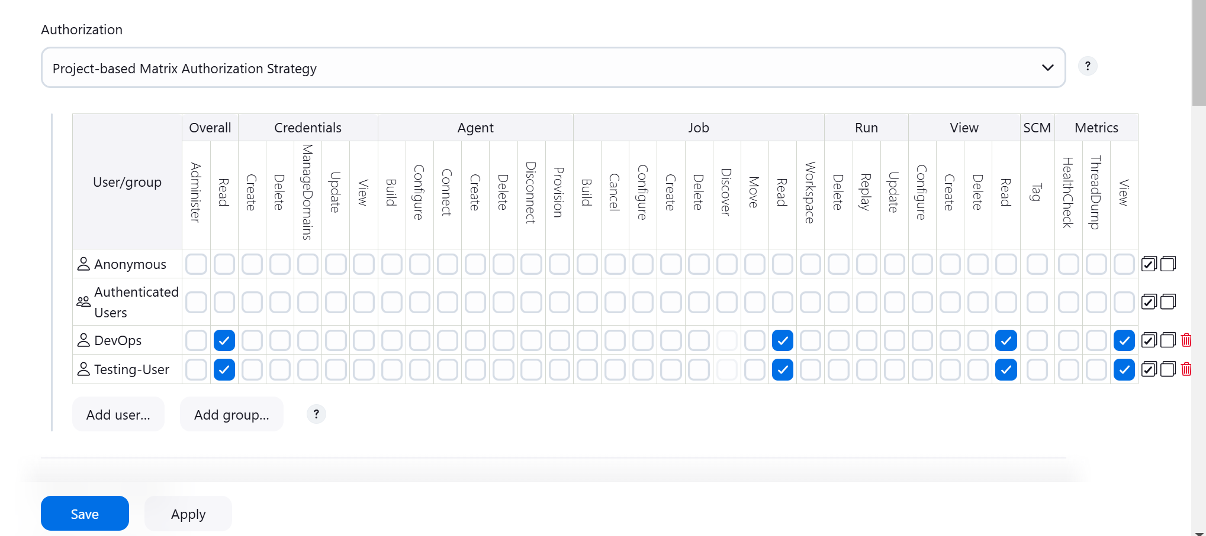  
  
  
  
  
  
  
4) Configure labels and restrict the jobs to execute based on label only.   
  
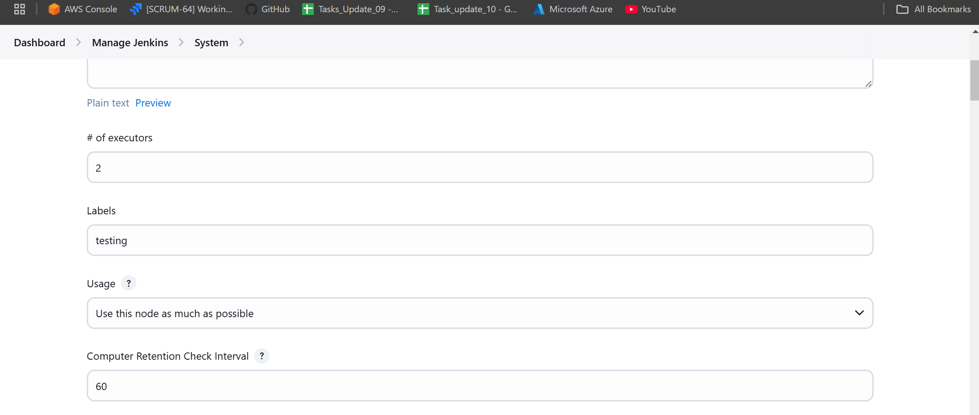  
  
  
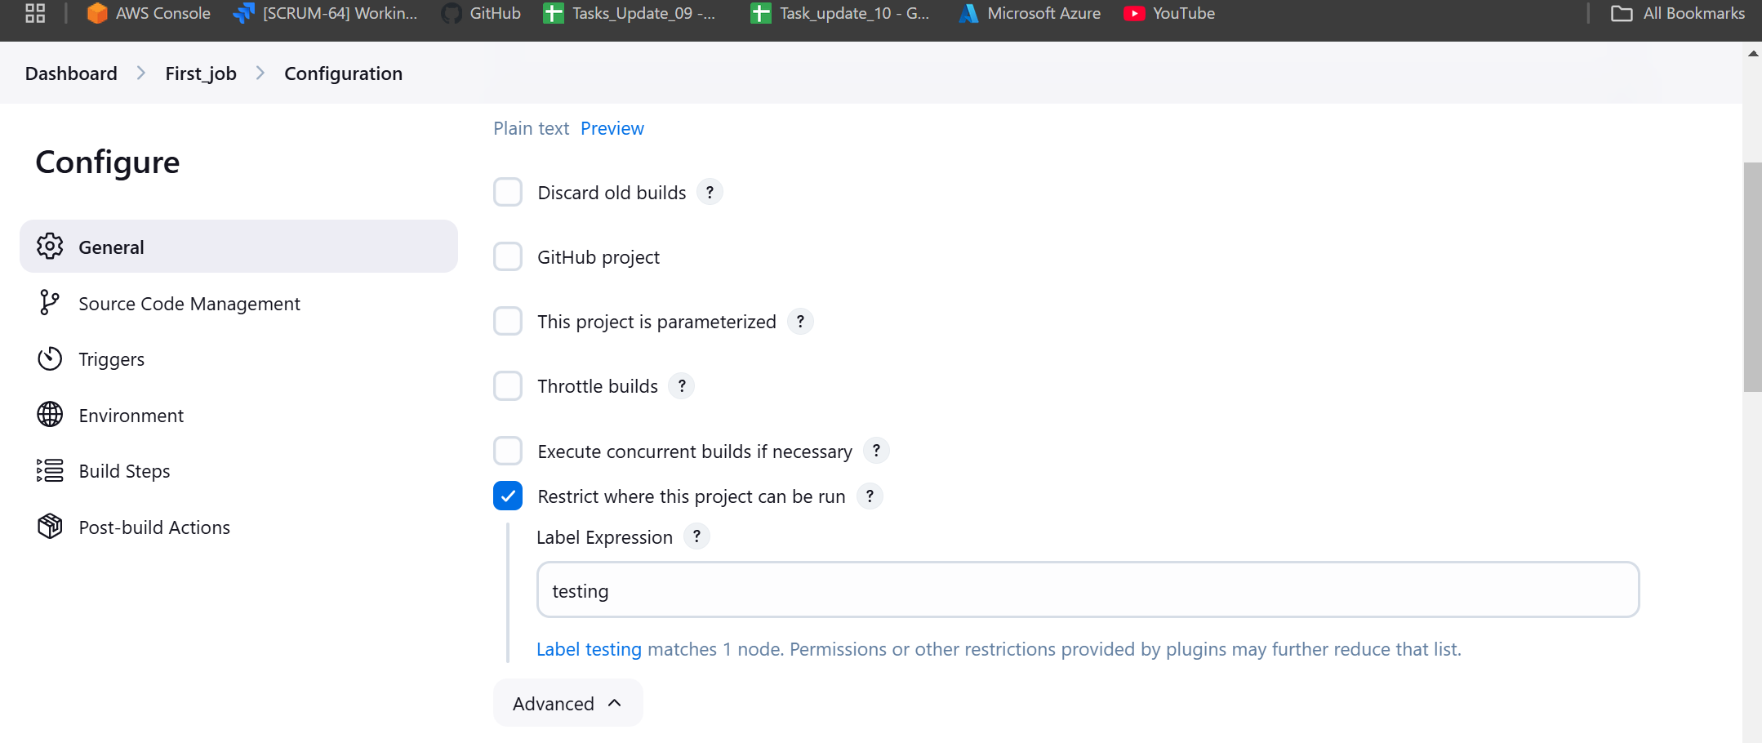  
  
  
  
  
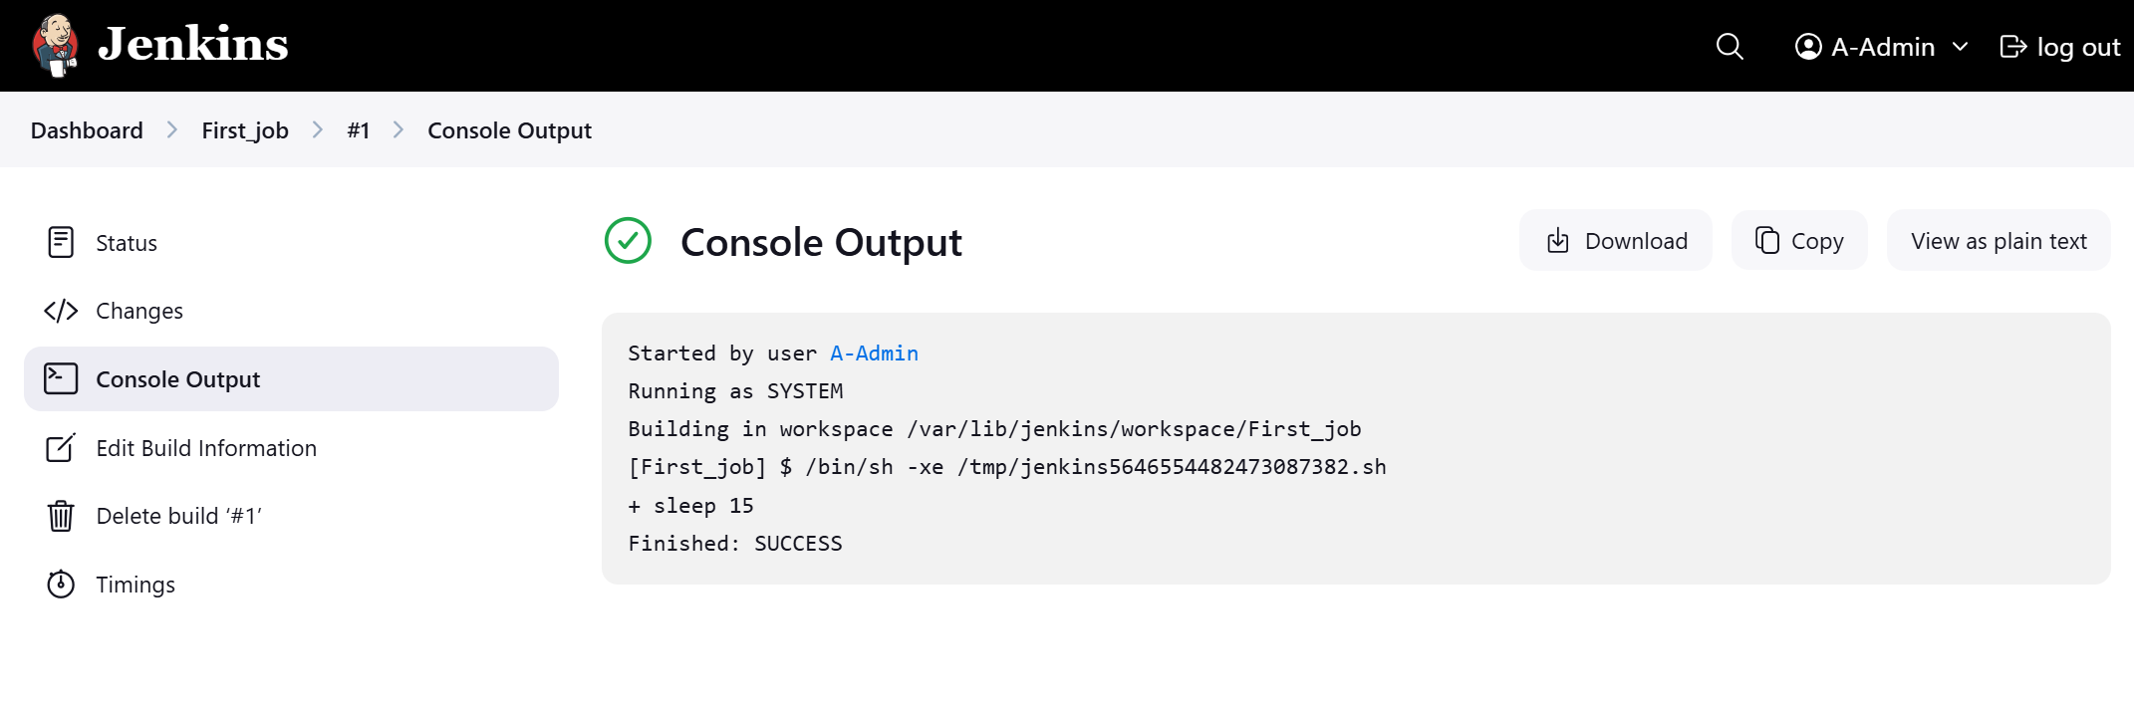  
  
  
  
  
  
5) Create three sample jobs using the below URL. [https://github.com/betawins/Techie_horizon_Login_app.git](https://github.com/betawins/Techie_horizon_Login_app.git" \t "https://app.slack.com/client/T03TRQ064Q0/_blank)   
  
  
  
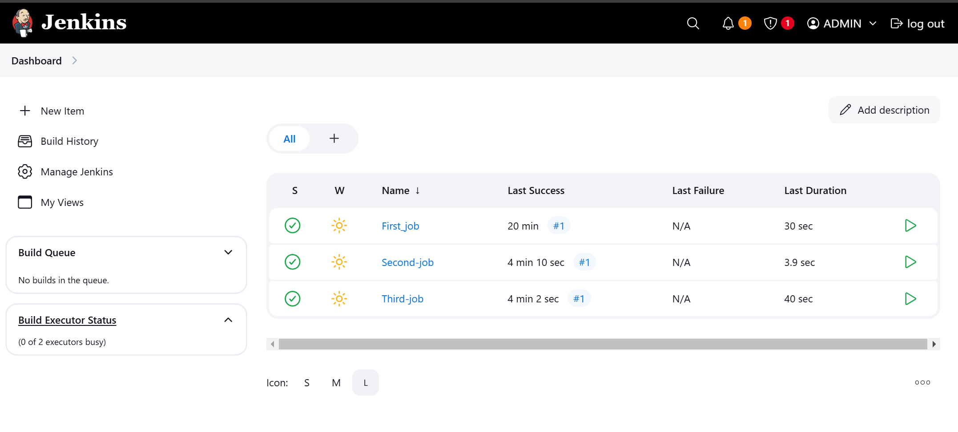  
  
  
  
  
  
  
  
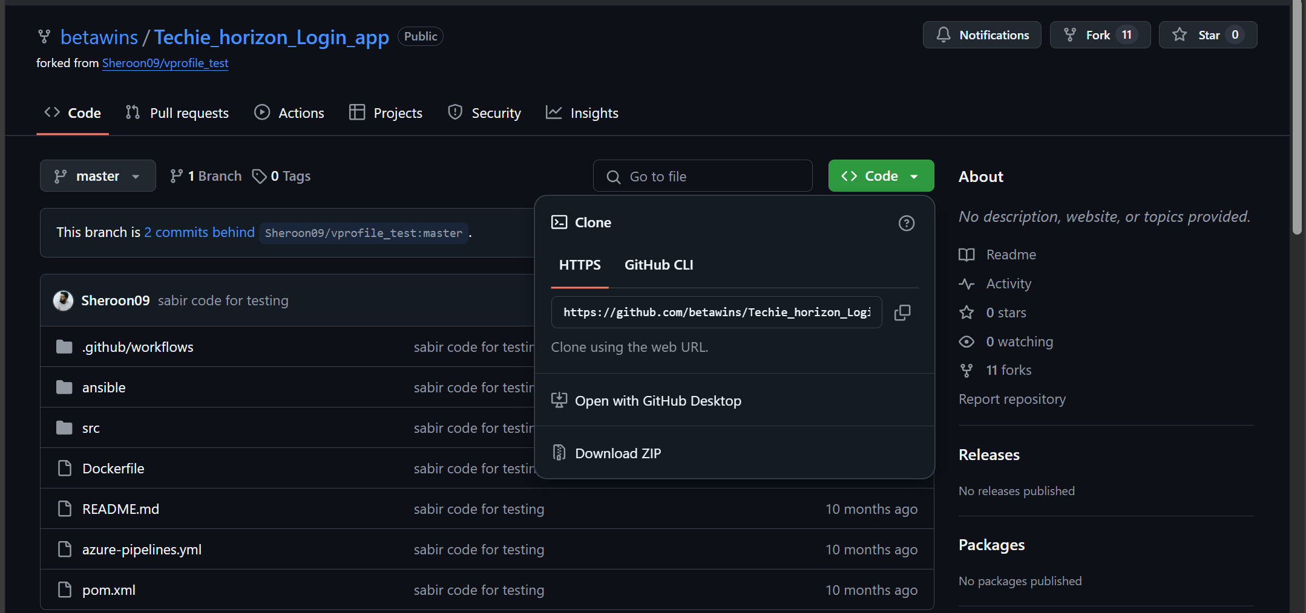  
  
  
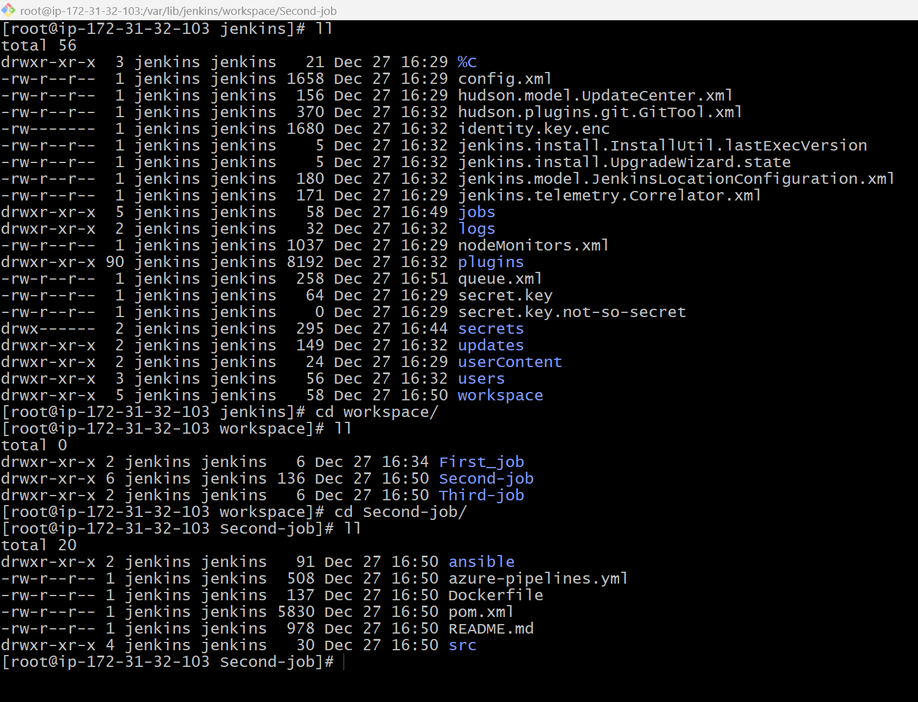  
  
  
6) Create one Jenkins job using git hub Private repository.  
